Module-3

Sol-1) a) Inferences
- Cars speed-
  - Skewness = -0.1139548, Kurtosis = NA
  - cars speed data is slightly left skewed
  - kurtosis can only we calculated when data is normally distributed or Skewness is zero

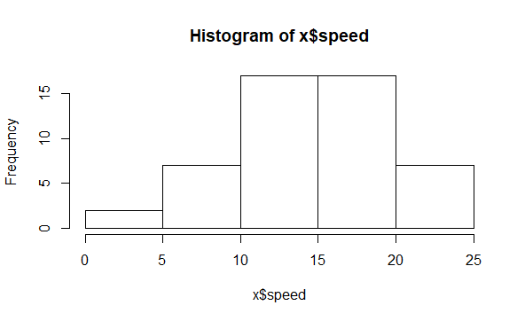
- Cars dist –
  - skewness - 0.7824835, kurtosis= N A
  - Dist data is highly right skewed, ‘+’ symbol indicate the direction of skewness and ‘0.7824’ indicate the magnitude of skewness.

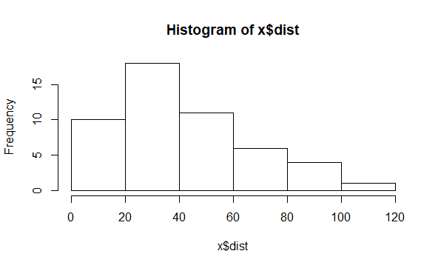

b) Inferences
- Top speed
- Skewness = 1.5814537,Data is slightly right
Skewed.

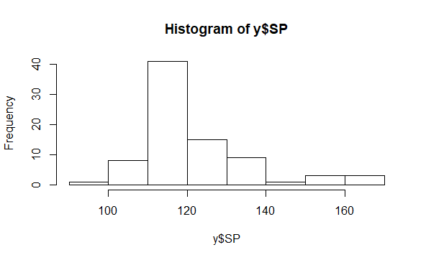
- Weight
- Skewness = -0.6033099, there is very small
Skewness in this data and it is very slightly left skewed

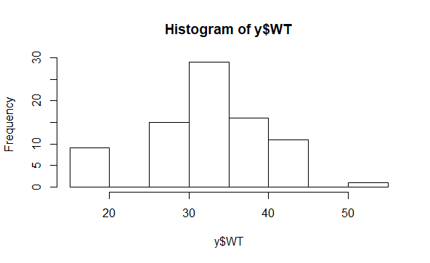

Sol-2) Inferences
- In histogram plot we can see that the data is mostly concentrated on the left side and
There is long tail towards the right side, so we can conclude that the data is right skewed
- By seeing the boxplot also it is clear that
Data is right skewed as the length of upper
Whishker is higher than the lower and there
are many outliners above the upper whisker.

Sol-3) N=3000000, n=2000, X(sample mean)=200pound
S=30 pound, n-1=1999(degree of freedom)

- For 94% confidence

Formula= X ± t(1-α)(n-1)*s/sqrt(n)

s/sqrt(n)= 30/sqrt(2000)=0.671

t(1-α)(n-1)= 1.882 (we will check value in T table)
so range is 200+(0.671*1.882) and 200-(0.671*1.882)

interval is (201.263 to 198.737)

- For 96% confidence

T(1-α)(n-1)=2.0551 , 2.0551*0.671=1.379
So interval is 200-1.379 to 200-1.379
Interval is (198.621 to 201.379)

- For 98% confidence
T(1-α)(n-1)=2.328, 2.328*0.671=1.562
So interval is 200-1.562 to 200+1.562
Interval is (198.438 to 201.562)

Sol-4) 1) mean-41, median-40, variance-25.52941
S.d-5.0526

2)Inferences
- Students marks are very less dispersed
- It is right skewed, which means data is mostly concentrated towards the left in the histogram plot.
- There are two outliners in the data 49
and 56

sol-5)there will not be any skewness

sol-6)when mean > median data will be right skewed

sol-7)when mean < median data will be left skewed

sol-8)positive kurtosis value indicates that the
peak of data is more narrower than the normal
distribution.

Sol-9)Negative kurtosis value indicates that the
peak of the data is less narrower or wider than the
Normal distribution

Sol-10)data is mostly concentrated towards the
higher magnitude or right side, therefore we can
say that data is left skewed or negatively skewed.

IQR-Q3-Q1=18-10=8

Sol-11)Inferences
- Range of data is less in boxplot 1 than that of boxplot 2
- Data of plot 1 is less dispersed whereas data of boxplot 2 is more dispersed
- There is no skewness in both the data

Sol-12)1)IQR- Q3-Q1= 12.5-5= 7.5, by multiplying this value with 1.5 and by adding and substracting it to Q1 and Q3 we would able to find the outliners in
the dataset.

2)The data is slightly right skewed.

3)If 25 will be replaced by 2.5, the box will
come exactly in middle and there will not be
any skewness in the data, and outliner will
also get removed

sol-13)1) Mode will lie between 4 to 8

2) Data is right skewed or positively skewed.

3) From both histogram plot and boxplot it is clear data is right skewed or positively
Skewed and there is some outliners in the
data.

